Lecture 9 – Biomaterials and Tissue Engineering

WHAT IS IT?

* Application of engineering principles and life sciences towards development of biological substitutes to restore, maintain, or improve tissue function or a whole organ
* Creation of new tissue for the therapeutic reconstruction of the human body
* Controls and stimulates target cells by a combination of molecular and mechanical signals, only to manipulate their functionality
* Replace damage or dysfunctional tissue, as well as, an organ replacement

MAIN COMPONENTS REQUIRED IN TISSUE ENGINEERING

* Sample cells from subject/donor; provides building blocks for engineering tissues and organs
* Cell scaffold; provides structure for cells to bind into until cells differentiate into desired tissue/organ
* Signal producers; stimulate growth of cells and their specialization into desire tissues or organs, as well as, ensuring proper functionality of engineered tissue

HOW DOES IT WORK?

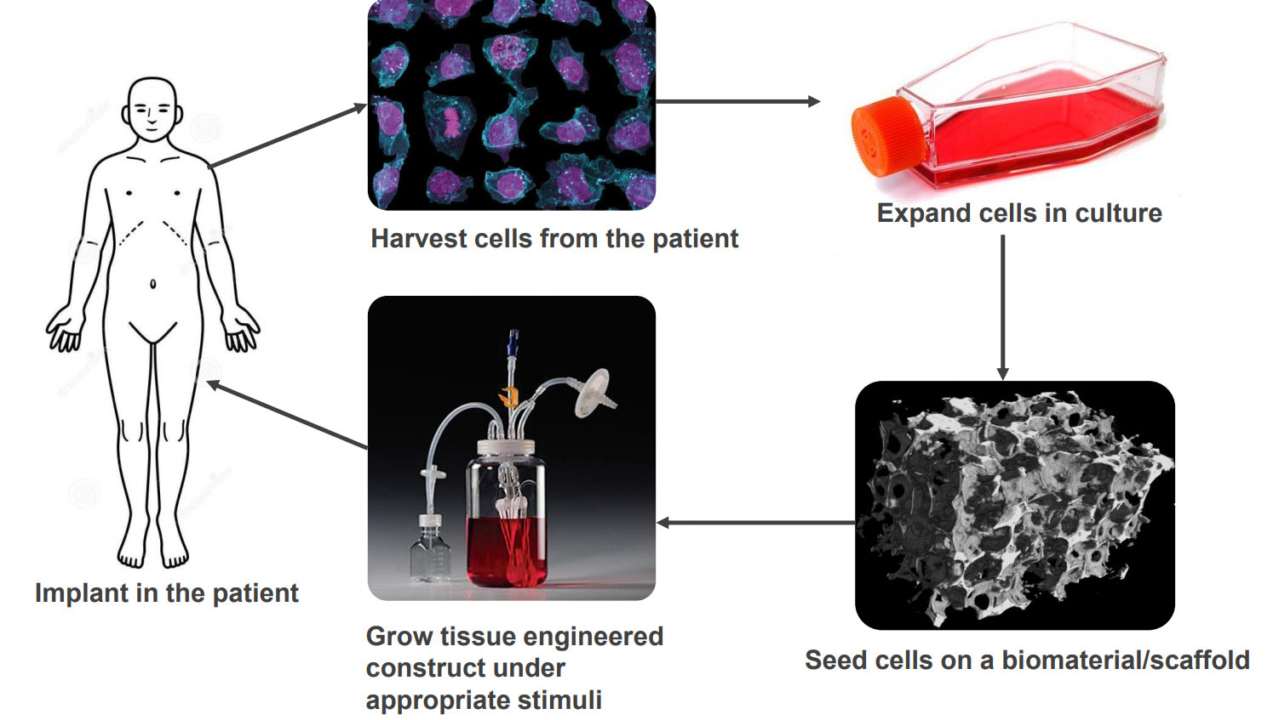

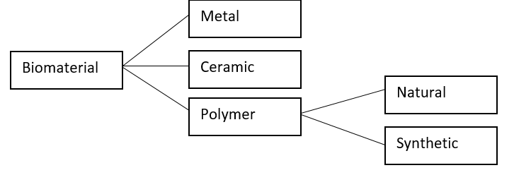BIOMATERIALS

* ‘Material intended to interact with biological systems to evaluate, treat, augment or replace any tissue, organ or body functionality’
* Some examples include; films, sponges, fibres, 3-D printed materials

NATURE VS SYNTHETIC SCAFFOLD MATERIALS

|  |  |
| --- | --- |
| Natural | Synthetic |
| * Ease of binding and architecture of tissue/organ already pre-determined * Since body able to recognize its own collagen cells, additional substances not required to promote binding of cells to scaffold * Hard to separate cells from collagen | * Relatively inexpensive and easier to design and obtain. * Material may be considered foreign to body, immune response may be initiated against the synthetic scaffold * Requires the use of inhibitors or hormones to increase chance of being accepted by a patients’ body. |

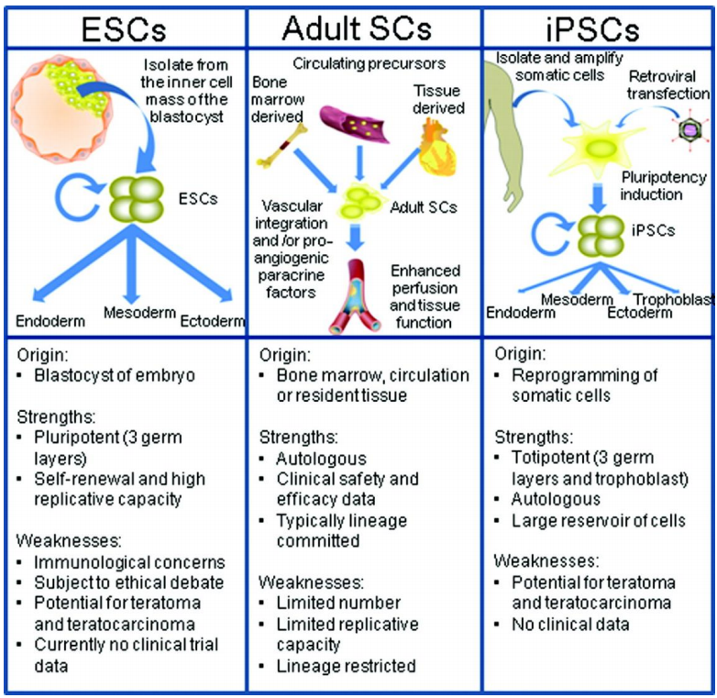

CELLS

* ‘An autonomous self-replicating unit that exists as a functional independent unit of life, or a sub-unit of a multicellular organism, only to carry out a particular function towards the organism as a whole’
* Cell culture
  + Cells from various tissue of plants and animals grown and cultured in an artificial environment outside the body
  + Involves:
    - Harvesting of individual cells from specific tissue
    - Maintaining cells in an incubator at body temperature (37oc) in a plastic or glass flask
* Type of cells:
  + Differentiated
  + Stem Cells (seen on right)

DONOR VS PATIENT’S OWN CELLS

|  |  |
| --- | --- |
| Donor | Patient |
| * Allows preservation of patient tissues and organs * Reduces invasiveness towards patients when conducting medical procedures. * Risk of rejection of donor cells once implanted in patient * Lack of suitable donors * Need to screen donors for medical conditions | * Little to no risk of cell rejection by patients’ body * Less processing required to obtain desired function * Limited donor sites to obtain cells and tissues from patient * Risk of infection when extracting tissue from patient, wounds produced during extraction * Underlying patient conditions may make cell extraction difficult/infeasible |

SIGNALS WITHIN TISSUE

* Biochemical, eg. Growth factors
* Mechanical, eg. Strain bioreactor
* Electrical, eg. Electrical stimulation